Happy Easter! Christians around the world today will be celebrating the good news that Christ is risen – Jesus is alive! And even though we can’t be together at church, we can celebrate in our homes… remembering the story of Easter and exploring it with some crafts, colouring and online activities.
Watch…

If you haven’t watched it already from our Holy Week links, then the story of Jesus’ arrest, death… and resurrection is here…
https://www.youtube.com/watch?v=HL8R158Ujp4

Enjoy…

Lots of great online resources at https://www.twinkl.co.uk/go
There’s two great e-books to listen & read along with – one of the easter story itself, and one called ‘The Easter Journal’, about how two children called Jaya and Ali celebrate Easter. You’ll also find an Easter wordsearch, and lots of interactive Easter activities to complete.
You will need to sign in (top right of the page), and enter the code OR9015 when prompted.
Hover your cursor over the ‘other resources’ tab just under the story book to explore all the other activities.

Make…

If you haven’t joined in already, then there’s till time to make an Easter Garden! You can go traditional (see the instructions at the end), or get creative and just use what resources you’ve got around the house. Make it as colourful as possible – to show the joy of Easter – and don’t forget to post/ send photos of your completed garden on the St. Margaret’s Facebook page… There will be prizes (we're not sure what or when you'll get them yet!) for some 'winners’!
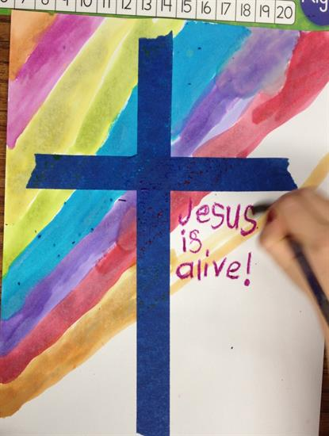
A colourful Easter cross… this one uses masking tape and water colours, but see what you’ve got around the house and adapt it! http://www.applesandabcs.com/2012/03/easter-cross.html

A handprint resurrection scene… it might be on a paper plate but it doesn’t have to be! Get out your coloured pens, paper, card, paint… whatever you’ve got!

A resurrection set… who knew there’d be a use for all those empty toilet roll tubes! Once you’ve clicked the link, scroll right to the bottom to subscribe (it’s free) and access the resource. Unsubcribe at your leisure! https://www.catholicicing.com/religious-easter-craft-for-kids-make/

Colour…

If you have a printer, then why not choose one of these great Easter colouring pages, colour it and then stick it in your window so everyone walking past can see it?
Easter Doodle http://www.religiousdoodles.com/uploads/2/6/1/6/26162462/easter.pdf
He is Risen - https://christianpreschoolprintables.com/wp-content/uploads/CPP/BibleColoring/Easter/EasterCrossColoring.pdf
May your Easter be filled http://www.religiousdoodles.com/uploads/2/6/1/6/26162462/mayyoureaster.pdf
Resurrection and life - http://www.freefuneaster.com/wp-content/uploads/Resurrection-Coloring-Page.pdf
For God so loved http://www.freefuneaster.com/wp-content/uploads/FNF_Easter-Coloring-PG23.pdf

