Welcome to another Something for Sunday! This week, we have another great Easter story… of the risen Jesus enjoying a campfire breakfast on the beach with his friends! I’m not sure if I fancy a campfire breakfast – especially not with fish – but maybe if the weather stays nice, you could enjoy a BBQ tea in the garden in the next week or so?!
Watch…

Jesus Forgives Peter – ever let someone down? Peter let down his friend Jesus BIG TIME, but Jesus still loved him, forgave him, and trusted him with an incredible job.
https://www.youtube.com/watch?v=Ppb9bKX1r7k&t=10s

Make, play and pray…

A campfire picture or model…
How amazed must the disciples have been to get to share a meal with the friend they had been missing so much? Why not create a campfire picture or model… coloured paper, tissue paper, sticks, paint, toilet roll tubes, lego… use whatever you’ve got around! As you create your model, why not tell God about the friends you are missing most at the moment. Ask him to keep them safe, and to bring you all back together again soon.
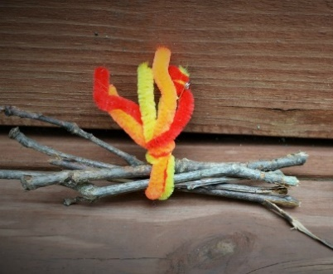
Here’s a few photos to inspire you…

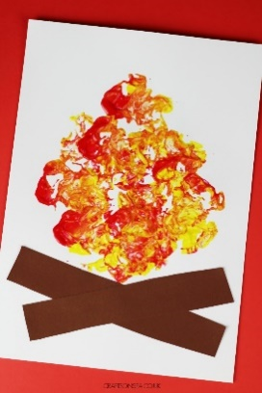
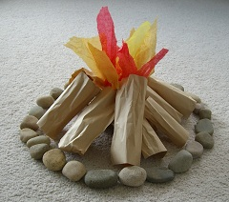

A tower…
Build a tower out of lego, building blocks, jenga…whatever you’ve got to build with! Make it as high as you can… and then (here comes the fun bit) knock it down! As you build it up again, say a quick thank you to Jesus – that when we mess up/ get knocked down, he forgives and rebuilds us. Whilst you’ve got the blocks out, why not have a go at building something else… a wall, a house, a space rocket… the things that we build have jobs to do, and God has jobs for all his friends. Ask God to help you understand what job he has for you to do.
Colour…

This great picture (printer needed) –
https://www.cbcgb.org/files/public/children/resources/Really%20Big%20Book%20of%20Bible%20Story%20Coloring%20Pages/pp269-270.pdf
Or why not have a go at the wordsearch on the next page?

